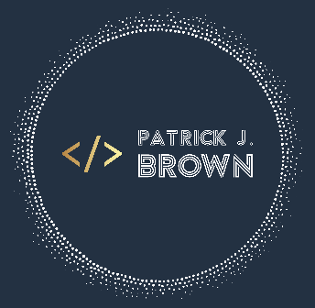

Patrick J. Brown  
  
pat@patrickjbrown.net  
www.patrickjbrown.net  
  
  
**Management Skills:**

* Technical project leadership
* Situational Leadership II   
  (SLII) training
* Interviewing
* Mentoring
* Inter-departmental partnership
* Strong technical and non-technical communication

**Technical Skills/Tools:**

* C#
* ASP.NET
* MS Visual Studio
* MS SQL Server
* Git, Github, Bitbucket
* Azure
* HTML
* CSS
* Javascript
* Java
* XebiaLabs Deploy/Release
* Jenkins

**Education**

Rochester Institute of Technology  
B.S. Computer Science  
Class of 2011  
Professional Experience

**Paychex – *Solution Lead (Software Engineer IV)* June 2016 – Present**

* Serve as the technical lead for Human Resources Online, a multi-purpose HR management application.
* Lead a team of 5 software and test engineers – delegating responsibilities, overseeing the team’s agile process, and assisting with release planning.
* Negotiate and coordinate closely with our partners in Product, Program, Legal, and UX to gather requirements, prioritize stories, and deliver features.
* Facilitate collaboration between the agile team and our partners within the organization, including database engineering, release management, ops, support, and other development teams.
* Foster professional development within the team, holding 1:1’s with team members to discuss performance expectations, review career goals, and assign appropriate stretch assignments to encourage growth.
* Cultivate the team’s culture by regularly organizing team gatherings, happy hours, and celebrations – even in a remote environment.
* Perform code reviews, oversee software deployments, and provide 3rd level support to our clients.

**Mindex Technologies – *Contract Software Developer* April 2013 – June 2016**

* Served as a contracted software developer for both Xerox and Paychex. Was an integrated team member in their agile scrum teams.
* Specialized in tuning application and database performance to meet increasingly complex business needs.
* Consistently earned accolades from clients, boosting my employer’s reputation as a source of IT talent. Impressed Paychex enough to be converted to a full-time employee.

**Parse3 – *Software Developer* June 2011 – April 2013**

* Designed custom web applications for clients. Types of projects varied by client, but included custom content management systems, workflow applications, and data feeds.
* Served as the lead of the company’s co-op / internship program. Represented the company at career fairs, conducted interviews, and trained and mentored students over the course of their internships.
* Held regular 1:1’s to discuss progress, and conducted quarterly performance reviews to submit to their university as part of their co-op experience.

Awards and Accolades

***PD & IT Director’s Choice Award***

Awarded by the Director of Product Development & Information Technology for proactively designing a utility to help the business meet a critical obligation to our clients. This saved hundreds of hours of manual labor, and maintained client confidence in Paychex during a hectic reporting season.

***PD & IT Hackathon – Most Likely to Succeed***

Awarded at the conclusion of a 72-hour Hackathon for providing a complete deliverable that would significantly reduce the effort required by our 1st and 2nd level support teams to perform research into client issues.